**Question:**

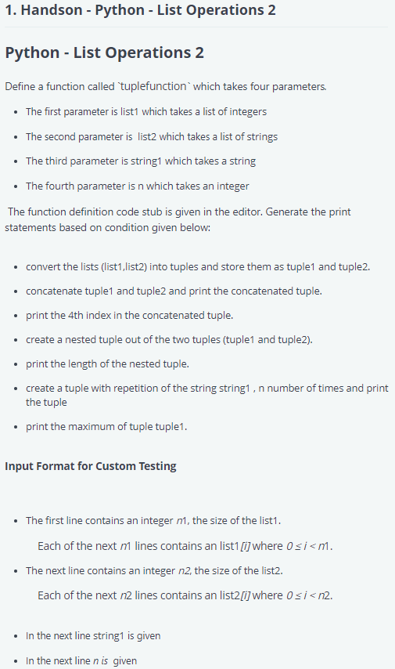

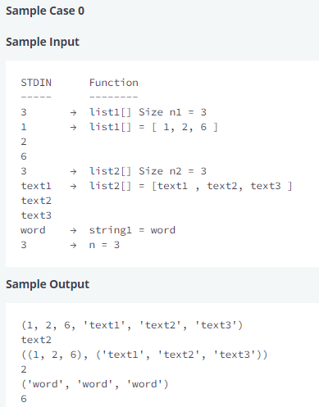

**Answer:**

# Complete the 'tuplefun' function below.

# The function accepts following parameters:

#  1. LIST list1

#  2. LIST list2

#  3. STRING string1

#  4. INTEGER n

def tuplefunction(list1, list2, string1, n):

    # Write your code here

    tuple1 = tuple(list1)

    tuple2 = tuple(list2)

    tclist = list1 + list2

    tc = tuple(tclist)

    print(tc)

    print(tc[4])

    nested = (tuple1,tuple2)

    print(nested)

    print(len(nested))

    rep = ((string1,)*n)

    print(rep)

    print(max(tuple1))

if __name__ == '__main__':

    qw1_count = int(input().strip())

    qw1 = []

    for _ in range(qw1_count):

        qw1_item = int(input().strip())

        qw1.append(qw1_item)

    qw2_count = int(input().strip())

    qw2 = []

    for _ in range(qw2_count):

        qw1_item = input()

        qw2.append(qw1_item)

    str1 = input()

    n = int(input().strip())

    tuplefunction(qw1,qw2,str1, n)

Your Output (stdout)

* **(4, 5, 6, 'jf', 'fg', 'fkhnt')**
* **fg**
* **((4, 5, 6), ('jf', 'fg', 'fkhnt'))**
* **2**
* **('word', 'word', 'word')**
* **6**

Expected Output

Download

* **(4, 5, 6, 'jf', 'fg', 'fkhnt')**
* **fg**
* **((4, 5, 6), ('jf', 'fg', 'fkhnt'))**
* **2**
* **('word', 'word', 'word')**
* **6**